**New Scripts**

There are two new fields at the line level of the customer order:

* Total Linear Feet: custcol_dm_linear_feet

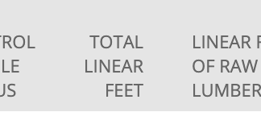

* Total Square Feet: custcol_dm_total_square_feet

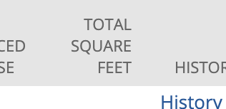

The calculations need to work as follows:

* Total Linear Feet: If the UOM on the line is Linear Feet then populate this field with the line Qty. If UOM on the line is Square Feet then use this formula to calculate the value: (12/<exposed face width value>)*Qty

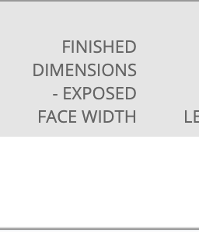custcol_dm_fd_exp_face_width

* Total Square Feet: If the UOM on the line is Square Feet then populate this field with the line Qty. If UOM on the line is Linear Feet then use this formula to calculate the value: (<exposed face width value>/12)*Qty